**HOME PAGE CONTENT:**

1. **Dataplus School Management Software** *(This should be used in place of what is written there already)*

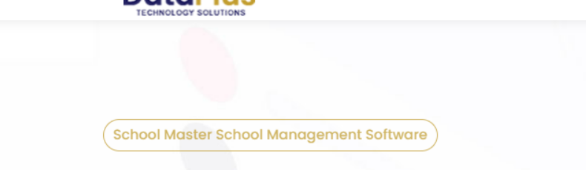

1. The **DSMS** is design to deploy a web application that is programmed with excellent record and identity management system that will be customized according to the school exams record sheet and administrative records. Give us a try today! ***(Can this be written below the motion text)***

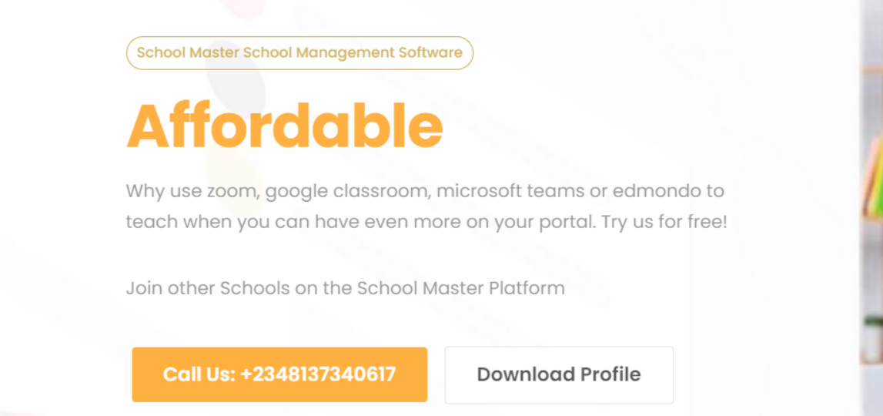

1. Kindly remove the “Download profile” below and input it under Portfolio at the top.

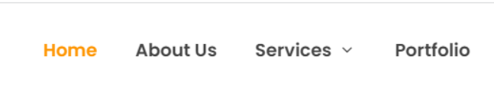

Example: You can download our Profile or just put Download Profile.

++ The page profile.html is being developed and profile can be downloaded there

1. **SERVICE:**
2. **SCHOOL PORTAL**

Manual methods of processing data in most academic institutions in Nigeria today has been a major set- back to the industry especially with the growing population of students and staff, this has a multiplier effect on the entire operation of the school. In a fast-changing world where manual data processing procedures are rapidly going into extinction, it is important to develop IT solution that will address and improve the educational system. It will automate every administrative process and connect the school to the world through free website and dedicated domain name that will be provided.

***Subsections:*** *(This should also be presented with creative images/graphic)*

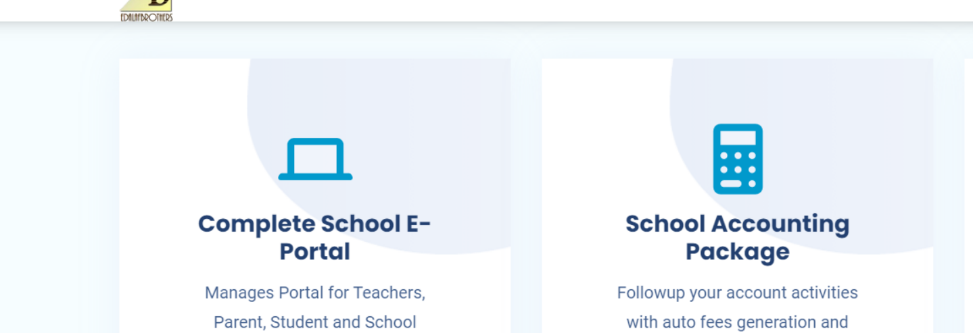

* **Admissions Management Module**

This runs the entire process of admission from the filling of form online, registration, taking E-entrance exams (if necessary). This process captures

* Students Data capture

* Parent Data Capture

* Registration Fee collection & Capture

* Optional Online Accessment/Pre-Accessment Module

* **Student Management Module**

This management module helps educational institutions create a 360-degree profile of each student throughout their school journey. It includes their personal and family information, photographs including demographic details, emergency contacts, health records, academic transcripts, extracurricular activities and achievements, attendance records etc. This information can be used to create ID cards for students, send updates to parents about their child’s attendance and academic achievements, and any pending payments to be made. This information can be accessed easily by teachers or the school administration to view and update student information and academic records and determine the best way to help their students learn and excel.

* **Learning Management Module**

The learning management module takes care of the learning activities of the educational institution. It creates abundant learning content for various subjects, courses and departments, based on the semester or terms. This module creates course notes and tests, class timetables, sets up automated online classrooms, assigns marks to students and generates their transcripts and grades, thereby effectively organizing all aspects of the academic calendar.

* **Communication Module**

Having a dedicated communications feature in your school management system can enable you to maintain personalized communications between teachers, administration and students. This feature helps set up a system that can handle multiple queries and feedback, direct them to the concerned department and send follow up messages and responses on time, reducing any delay in resolving enquiries or other issues. It can be used to send notifications and alerts regarding attendance, exam timetables, pending payments, assessment outcomes, holidays, school festivities and other important events.

* **E-Library**

This module enables e-books download, view only options, archiving, user access logs, addition/removal of books, access control.

* **Transport**

Onboarding, Signups, Scheduling, Communication, routes management, vehicle management, driver management, fleet management (fueling, maintenance etc)

* **Finance**

Financial management module will enable schools to connect various departments such as admissions, finance, hostel, cafeteria, library and transport.

* **Human Resource Management**

Staff onboarding, exit, leave, holidays, absence, salary, Staff roles, categorization etc

* **Lives Classes**

Take live online classes with students from anywhere in the world. Teachers can incorporate videos, images, file sharing, etc. Everyone can contribute to the class in real time.

2. **MOBILE APPLICATION**

* **Lives Classes**

Take live online classes with students from anywhere in the world. Teachers can incorporate videos, images, file sharing, etc. Everyone can contribute to the class in real time.

* **PTA Meeting**

Parents can join PTA live via the mobile app and also make contributions, suggestions and partake fully during this period.

* **Admission**

All admission can be done on the mobile app. This is process is very easy to use and navigate.

* **Lives Classes**

All payments including school fees, uniform payment and other fees can be paid via the mobile app.

* **Live Chat**

Parent, Teachers and Students can communicate via the chat platform on the mobile app. This gives parent easy access to get update on their children’s performance in school.

* **Mails**

Mails can be sent via this mobile app.

Can we have Lively Animation to ask the question?

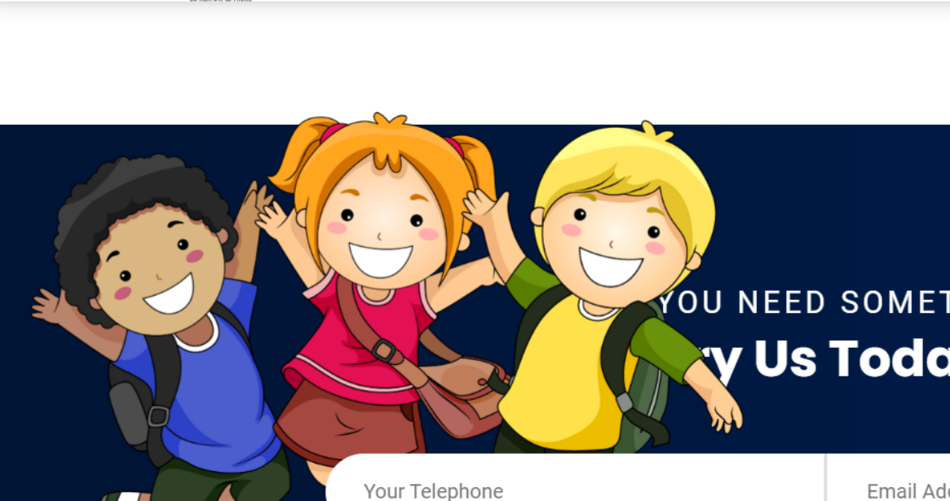

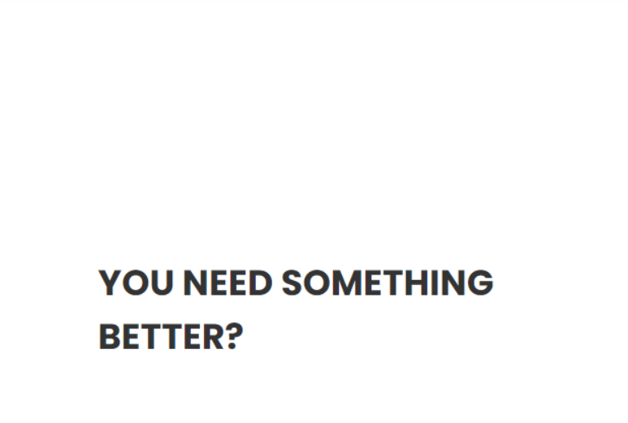

Watch Video:

Kindly help with educational videos

* **VISION:**

The vision is to create a strong school management software to enhance effective process in the educational system. To be the leading School management software provider locally and globally.

* **MISSION**

We want to create value in the Educational system through the deployment of this software application. The organization will be addressing and solving the problem of;

* Lack of detailed data of Students.
* Lack of proper communication channel between teachers and parent
* Inadequate information channel
* **CORE VALUES**

1. Excellent Service Delivery
2. Promptness
3. Transparency
4. Integrity
5. Authenticity

**Other Observations**

* + - 1. Please can we have a different nice font from the ones used now? A font that looks clear and bold.
      2. Kindly help increase the font. They look small especially the home page contents.
      3. Please let’s explore the blue colors more as well. This can enhance the font.
      4. Kindly remember to use male corporate animations, images or graphic on the website for gender equality like Mr Bola suggested previously.
      5. For the details under the website development, kindly help with content as an expert in the field.
      6. Watch video part: Please come up with illustrative educational videos like Edalaf.

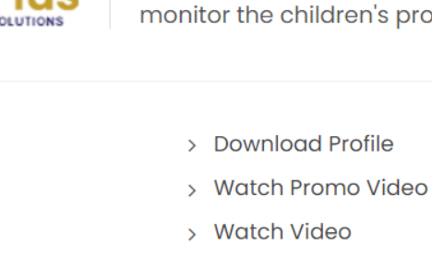

* + - 1. Kindly use images that are clear and sharp. The first image on the homepage is very nice but it seems blurry. Can anything be done in this regard?